**M3 - explain the principles and uses of proportional control**

**Introduction**

In this assignment, I will explain the uses and principles of proportional control. They are three types of proportional control and they are loop stability, proportional control a proportional integral derivative control.

**Loop Stability**

Loop stability within a control system represents the input bound and the output bound. This is also known as BIBO Stability (Bounded Input/Bounded Output). The system needs to be stable by magnitude. Magnitude is the greatness of the position. The input has a maximum value that is set within the boundaries. It needs to be within the boundaries. This helps the output not becoming large and it can prevent it from ‘blowing up. The picture shows the stability and the instability. Within the red line is the stability and outside of the red line is the instability.

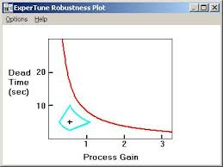

**Proportional control**

Proportional control is simpler out of the three. They are equations for the ‘error’ to be found out. The equation is the following:

**Error = input – measured output**

The ‘measured output’ is the output of the sensor and this equation is input take away output which equals the error.

The equation for control effort is the following:

**Control Effort = Kp * Error**

As you can see, the aim for these equation is to find out the control effort. ‘Kp’ is a constantly representing the gain proportional controller. This means that it is proportional to the error once the error has been found out.

**Proportional integral derivative control**

Proportional-integral-derivative control also known as PID is a controller that is used in control systems. An example could be that if they is 10 volts, each 1 volt will take time for to achieve its objective.

They are three separate algorithms: proportional, integral and derivative. Each of them can be abbreviated as P, I and D.

* Proportional – the required reaction based on the current error
* Integral – the required reaction based on adding up all the errors
* Derivative – the reaction based on the rate of change of the error

